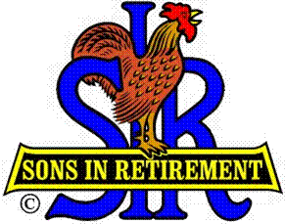

Las Trampas Branch 116

Luncheon Meeting Agenda

July 17, 2017

11:30 AM
- Call to Order – Big Sir.
- Welcome
- Pledge of Allegiance.
- Invocation: Michael Barrington
- Introduce Head Table
- Little Sir: Marty Katz
- Chaplain: Michael Barrington
- Guest Speaker – Ted Clement & Debra Tolwhite
- Introduce Guests & Visitors
- Guests:
- Visitors:
- Introduce New Members (if any)
- Big Sir Comment
- 2018 Nominations (must be finalized by August meeting)
Openings: Sam Beret (Attendance) & Pat Bermingham (Greeter)
- Sunshine Report – Matt Arena
- Storyteller – Andy Benz

11:45 PM – Lunch
- Raffle Drawing

12:15 PM
- Committee Reports

12:30 PM
Little Sir:
- Introduce Guest Speaker – Ted Clement & Debra Tolwhite
- Ask June Birthday guys to stand / sing Happy Birthday (Paul King & Robbie)
- Sign God Bless America.

